**<KOI ORDERING SYSTEM>**

**Documentation**

**TABLE OF CONTENTS**

**1** **Introduction 3**

1.1 Overview 3

1.2 Scope 3

1.3 References 3

**2** **Project scope 4**

**3** **FUNCTIONAL Requirements 5**

3.1 Roles 5

3.2 Use Cases Diagram 5

**4** **NON-FUNCTIONAL Requirements 6**

4.1 Usability 6

4.2 Reliability 6

4.3 Performance 6

4.4 Supportability 6

4.5 … 6

**5** **database design 7**

**6** **source control 8**

Introduction

## Overview

#### This is the project of team KoiJP to connect with all Japanese KOI farms for traveling to view the beautiful view, the special KOI fish of Japan. This web will have a tour or custom tour for tourists. Tourists choose a tour on this website. After the tour ends, if tourists like any KOI fish in this farm and like to buy some KOI fish, they can contact the manager dealing with the KOI fish price then go back to the web to make orders. Tourists deposit in advance and are paid in full upon receiving the KOI fish.

## Scope

· In-depth marketing or promotional functionalities beyond a basic introduction to the farms and services.

· Full logistics management of fish transportation outside Japan.

· Farm-specific Koi fish breeding and operational management systems.

## References

# Project scope

<https://app.diagrams.net/#G15fVe_kqHt8IsTN07IwUVGy3xa5xsFUho#%7B%22pageId%22%3A%227XHrv0Oi1xqDmsPc6SA8%22%7D>

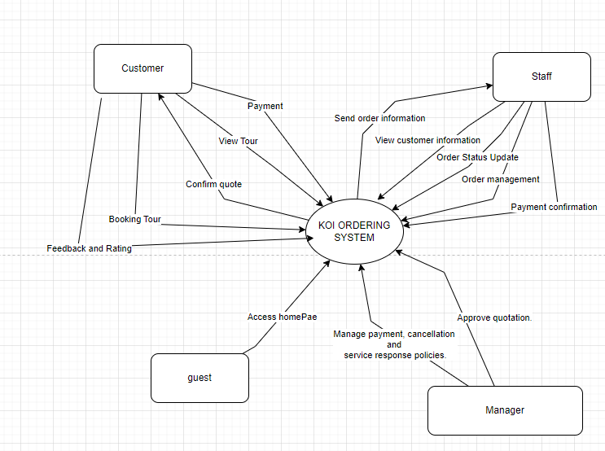

# FUNCTIONAL Requirements

FUNCTIONAL REQUIREMENT

### 1. Guest

* **Access home page:** view home page, can search the trip

### 2. **Customer**

* **Search Trip**: Guests and registered users should be able to search for available trips.
* **View Information**: Guests can view trip-related information without logging in.
* **Register**: Guests can register on the platform.
* **Add to Cart**: Customers can add trips to a cart for booking later.
* **Book An Available Trip**: Customers can book trips from available options.
* **View Available Trips**: Customers can view available trips in the system.
* **View Trip**: Customers can view detailed information about booked trips.
* **Make Payment**: Customers should be able to make payments for booked trips.
* **Manage Ordered Trip**: Customers should be able to manage trips they have booked, such as rescheduling or cancellations.
* **Cancel Trip**: Customers can cancel booked trips.
* **Manage Koi Order**: Customers can manage orders related to "Koi orders" (possibly a special feature of the system).
* **Live Chat**: Customers should be able to initiate a live chat for support.
* **Rate and Feedback**: Customers should have the ability to rate trips and provide feedback.

### **3. Manager**

* **Manage Staff and Users**: The manager is responsible for managing both staff and user profiles, including adding, updating, and removing staff members.
* **View Reports**: The manager has the ability to view various reports related to system operations, customer activities, and staff performance.
* **Manage Farms**: This could involve overseeing inventory, operations, or special services related to the business's farms (if relevant to the context).

### **4. Delivering Staff**

* **View Information of Orders**: Delivering staff can view the details of the orders assigned to them, allowing them to prepare and deliver the products/services.
* **Manage Orders**: They can manage the orders they are responsible for, which might include confirming delivery, updating the order status, or handling returns.

### **5. Consulting Staff**

* **View Customer Information**: Consulting staff have access to detailed customer information to assist them in offering personalized services or handling specific requests.
* **Send Details to Customers**: They can communicate trip or order details to customers, ensuring that all relevant information is conveyed.
* **Manage Koi Orders**: If "Koi Orders" refer to a specialized service, consulting staff can manage these orders, ensuring that customers receive the appropriate service.
* **View Information on Tours**: Consulting staff have access to detailed tour or trip information and can provide this to customers.

### **6. Sales Staff**

* **Manage Orders/Trips**: Sales staff are responsible for overseeing customer orders or trips, ensuring they are properly booked, confirmed, and fulfilled.
* **Send Approval Quotations**: They can send approval quotations to customers for special or customized trips, based on customer consultations.
* **View Status of Consultations**: Sales staff can track the status of customer consultations to ensure follow-ups and that no request is missed.
* **Input Canceled Trips**: They are responsible for managing and updating records of canceled trips.

### **7. Administrator**

* **Manage System Maintenance**: Administrators handle the overall system upkeep, ensuring the platform is up to date and operational.
* **Manage Accounts**: They also manage system accounts and possibly have higher-level access to all the other staff functionalities.
* …

## Use Cases Diagram-

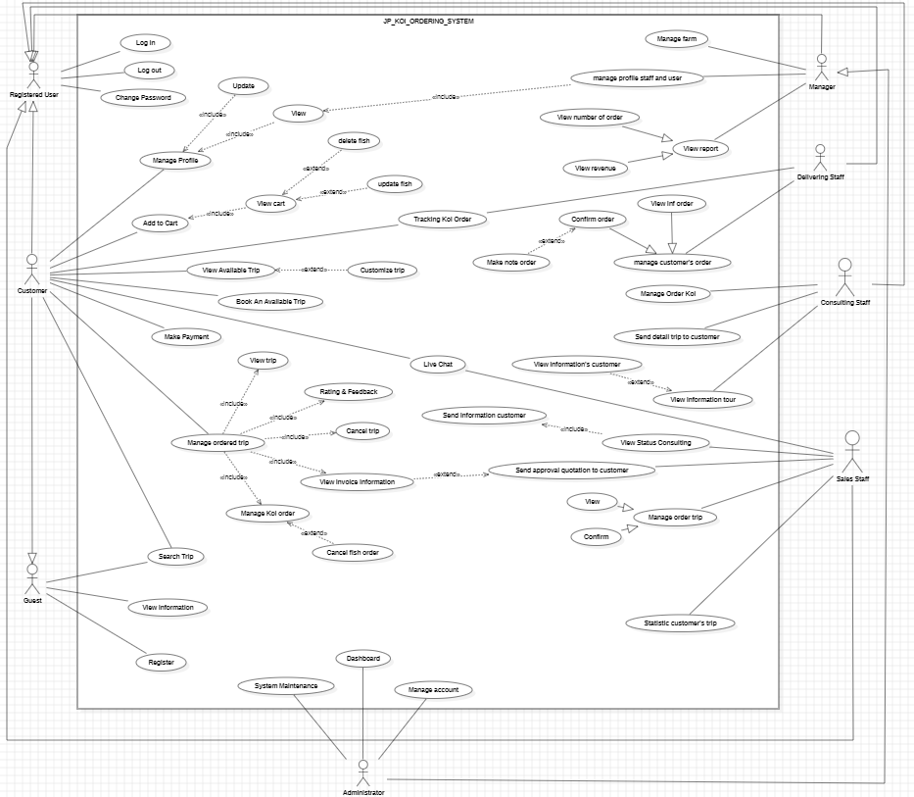

# NON-FUNCTIONAL Requirements

*[This section describes the non-functional requirements of the system. Some examples are listed as below]*

* The system must be easy to use and navigate, especially for customers who are booking tours or purchasing Koi fish online.
* The system must be consistently available and provide accurate, up-to-date information regarding tour schedules, Koi fish availability, and customer transactions. It should handle failures or downtime gracefully, minimizing disruption to users

# Screen Flow

<https://lucid.app/lucidchart/6e9daeaa-18c7-410a-b88b-1da477d6904c/edit?page=0_0&invitationId=inv_e6fa9fe3-95d2-4566-be0d-821fd6e4b25c#>

Admin

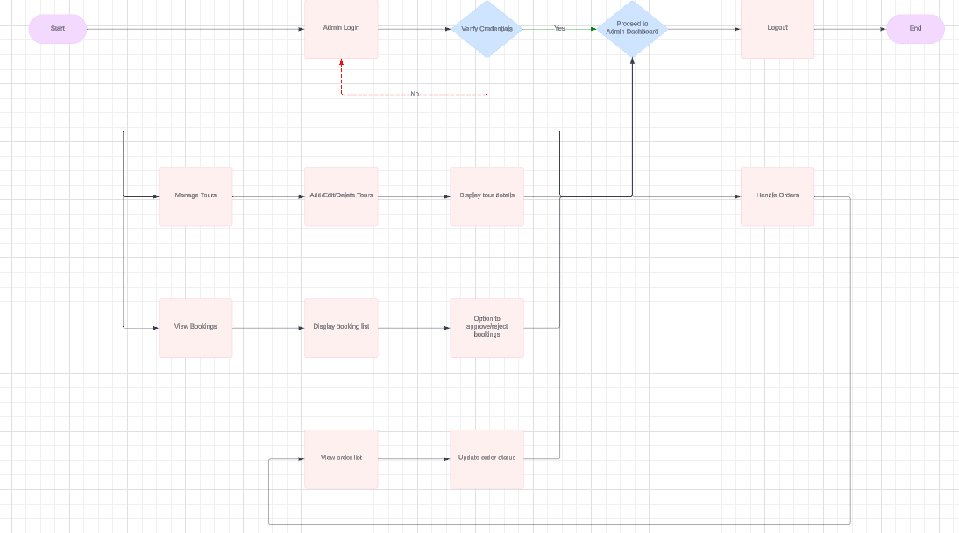

User

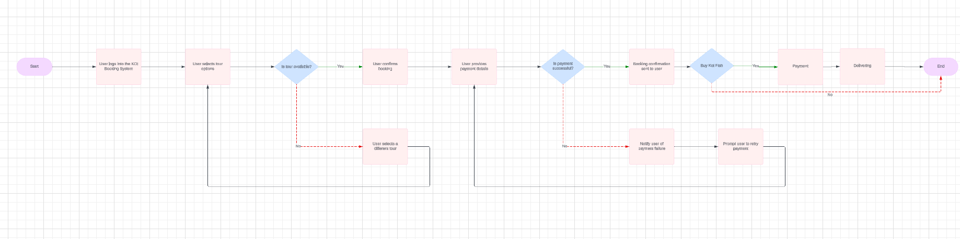

# database design

<https://app.diagrams.net/#G1cupDbgJJpIcnoZc6vd3DmMiPKiX8Lfk1#%7B%22pageId%22%3A%22kfjH82A-2b0isO7vrH4B%22%7D>

# source control

<https://github.com/hwink09/JP_KOI>